|  |
| --- |
| Beautiful Babe Boutique  Web application  Crystalyn Wegner |
| Project Proposal & MVP |



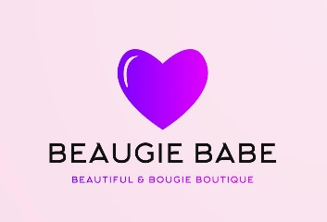

## Beautiful Babe Boutique Project Plan

### **Overview**

### 

### This proposal is to create an e-commerce web application that sells different name brand boutique clothing at a one stop online shopping experience. The web application will include a database of available merchandise for purchase. There will be a search field implemented for the customer to search for a type of item they are looking for and the web application will display the results that are available. It will allow users to add items into a virtual shopping cart and purchase. Users will also be able to login and see their purchases as well as ask any questions needed to the boutique owner or operator.

#### Problem

Currently many boutique brands will not sell a wholesale product at a wholesale price to a boutique owner unless they have a brick-and-mortar location or a e- commerce website. Having a brick-and-mortar boutique has a lot of overhead costs when starting a small business. It must have employees to run the shop and a physical location also has its costs. For example, location rent, electricity costs risk of theft and much more.

**Value**

Creating an e-commerce boutique web application will allow a small boutique owner to get started selling many sought after brands at an affordable wholesale price. It allows them to eliminate all the overhead cost of the brick-and-mortar business model plan for a small business.

**Personas**

There are three different possible personas that this web application would target.

The first would be a young woman in high school or college in her adolescent to young adult years about 15-25. Looking to shop and purchase the latest and most popular brands at an affordable price.

The second would be a young woman about 25-40 with a career. She would be shopping on this application for weekend wear or after her 9-5pm job.

The third persona would be a significant other or family member of a young women in the first two personas that maybe shopping to surprise her with her most coveted brands of clothing and accessories.

gg

**Minimum Viable Product (MVP)**

The structure and flow of this web application will consist of the user or customer to launch the web application from the world wide web. It will display the home page with a search bar and a page bar with different categories or products listed. The user can type in a product description and if the key words are recognized by the database the results will be displayed. If not no results message will be displayed for the user.

The user can add items to a virtual shopping cart and checkout to purchase the items they have selected. I plan on tieing in a third party payment system such as shopify to take a payment for the items purchase and create an order number sending it to a database in Postgres. The item inventory will also be stored in Postgres database.

The languages that will be used the code the application will be JavaScript, CSS, HTML, SQL to name a few. For the design of the UX I will be using a bootstrap and angular framework.

User/Customer UI will be able to:

1. Login to a created account to view orders and ask questions to the boutique owner/operator.
2. Search in the search field for an item they are shopping for.
3. Add items to a shopping cart and checkout and pay for the items using a third-party payment SaaS provider.
4. Navigate through the website for products for purchase in different categories.

**

be